Storing information in Database using

Node Red and Firebase

Node-RED is a programming tool for wiring together hardware devices, APIs and online services in new and interesting ways. It provides a browser-based editor that makes it easy to wire together flows using the wide range of nodes in the palette that can be deployed during its runtime in a single-click.

**Browser-based flow editing**

Node-RED provides a browser-based flow editor that makes it easy to wire together flows using the wide range of nodes in the palette. Flows can be then deployed during runtime in a single-click. JavaScript functions can be created within the editor using a rich text editor. A built-in library allows you to save useful functions, templates or flows for re-use.

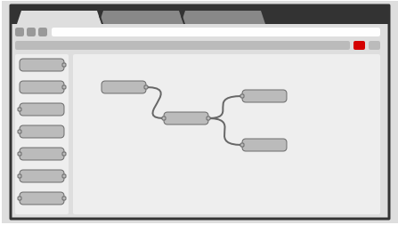

We use firebase for database creation.

**The steps are as follows:**

**Step 1**: Create an account in firebase and choose a name for your project, choose the country too.

**Step 2**: On the console of Firebase, go to Authentication and enable email verification.

**Step 3**: From the database option copy the weblink for your database

**Step 4**: Change the view of the database so that it becomes public.

**Step 5**: Now add data and variables by clicking on the ‘+’ sign adjacent to the project name.

**Step 6**: Go to Node Red, in the manage palette 🡪 search for firebase 🡪install Node-Red-contrib-firebase

**Step 7**: From the nodes installed, select firebase modify node, also add an inject node

**Step 8**: Set up firebase node by entering the link copied earlier and setting the authentication type as null

**Step 9**: Mention the child path, that is, the name of any of the variables created. Connect both nodes and press deploy.

**Step 10**: To create a new variable every time, select push option.

**Step 11**: For the circuit we need, the configuration is shown below. For the gpio ports, the pins to be set for output or input are chosen.

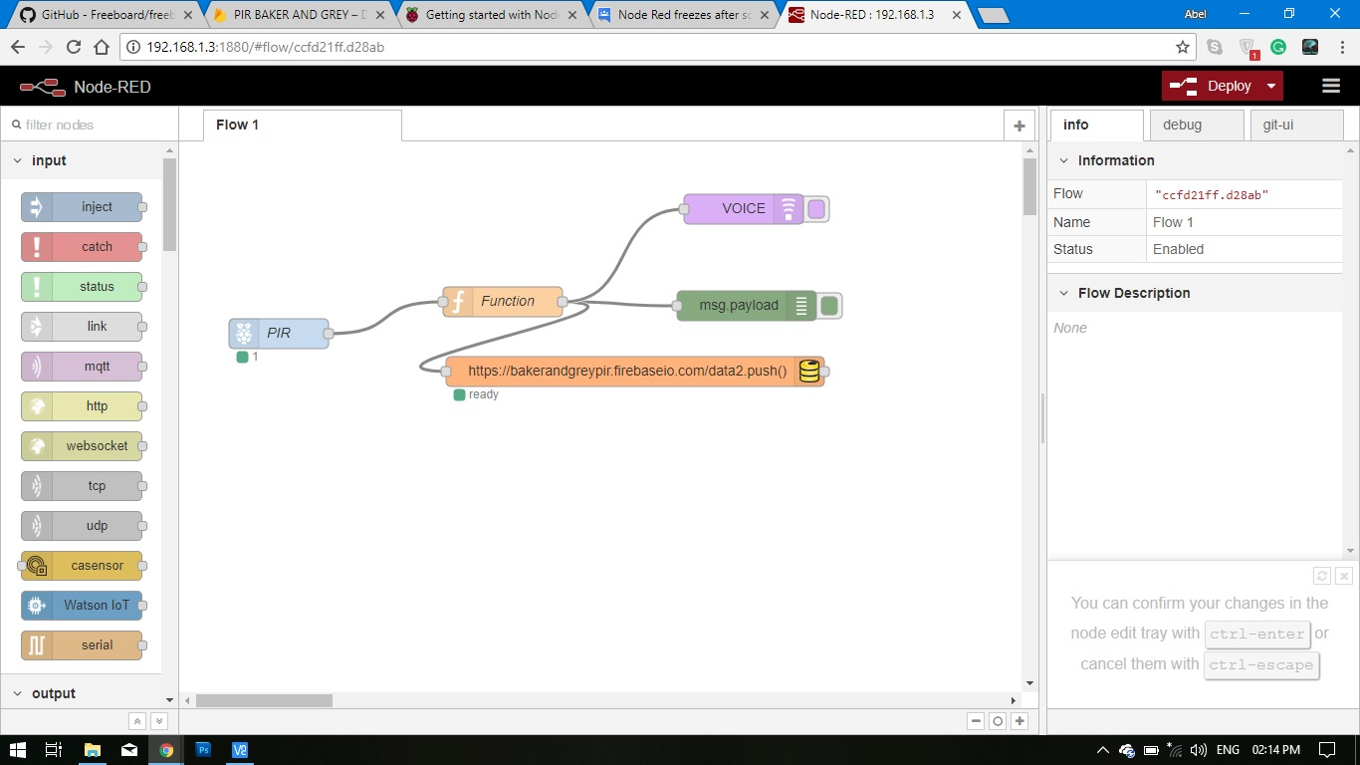

**Step 12**: Now the circuit is placed on the breadboard

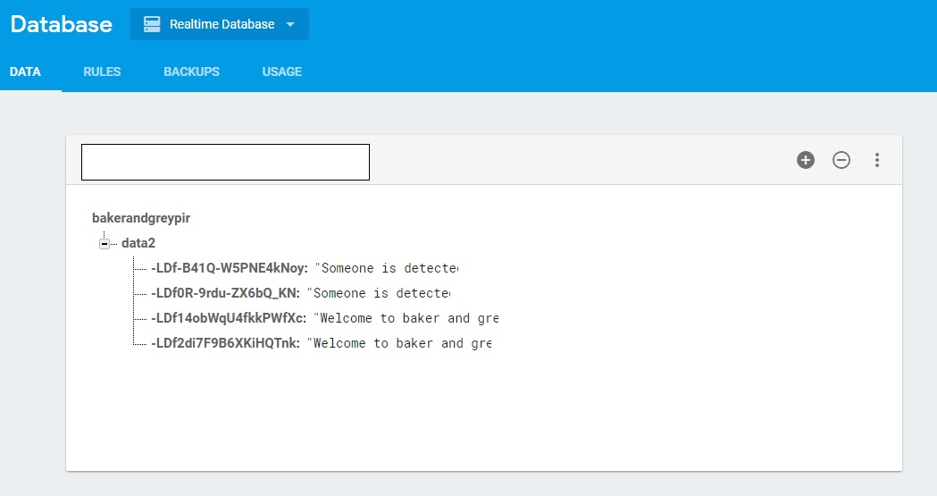

Every detection by the PIR Sensor now produces a record in the database. The database can be viewed anywhere using the database link previously found.